`
Vulcan Activity Tracker
Weekly Report

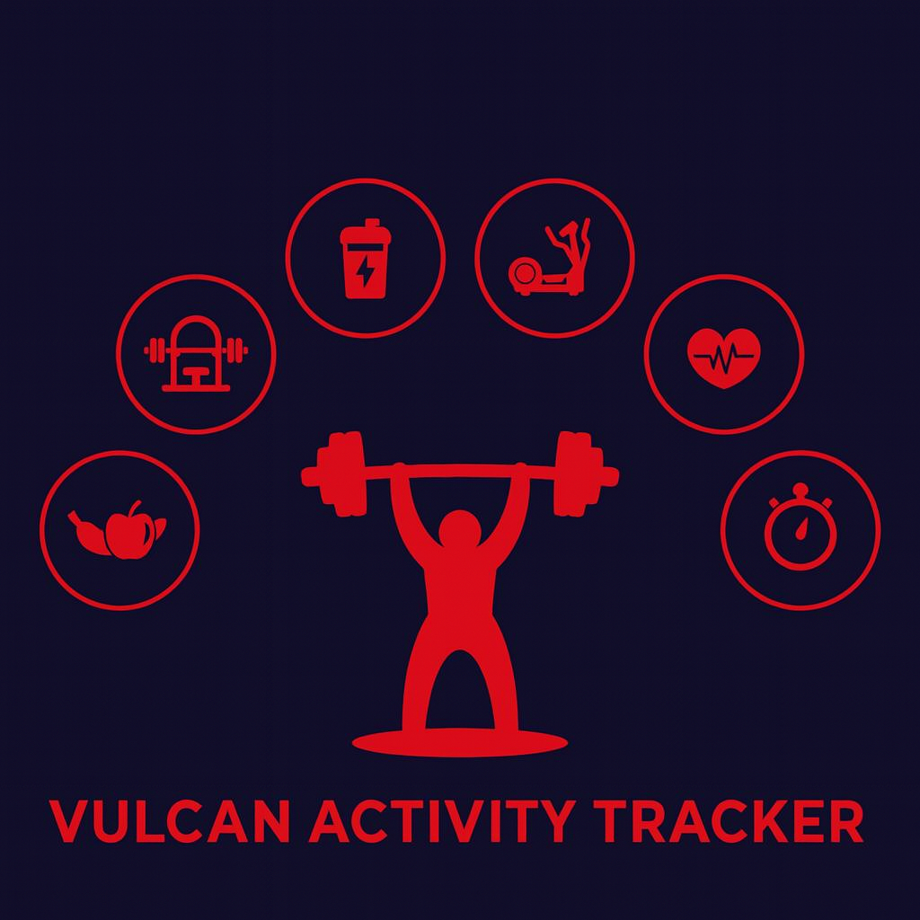

Week 13
Team Members:
Margo Bonal
John Gerega
Luke Ruffing

Professor: Dr. Weifeng Chen

Course: CMSC-4920-Senior Project II
School: Pennsylvania Western University

Table of Contents

Project: Vulcan Activity Tracker 2
Goals Accomplished: 2
Team Progress: 3
Gantt Chart: 4
Week 14 Plan: 4
Member Contribution: 5

Project: Vulcan Activity Tracker
To complete the proposed goals in previous week’s report, our team followed a strict schedule of daily progress and communication. Our team had 4 main goals to complete, which were to finalize some more of the components of the tracker, continue debugging previously added features, prepare the final presentation for our project, and to finish up the user manual for our project. Since each goal needed time allocation for development and testing, we assigned each goal priority based on how they were connected to each other. Throughout the discussion, we decided that finishing the user manual was the most important goal to finish this week. We wanted to get the user manual out of the way so we can start practicing for our final presentation.

Goals Accomplished:
One of the goals accomplished this week was cleaning up some of the components used in certain features. We did this to give a cleaner overall feel to our project by making the user experience feel smoother.
Another goal we completed this week was debugging some issues we previously ran into while using the tracker. By revisiting these issues we were able to identify the root causes of these small bugs, and were able to fix them.
The most important goal we completed this week was making the draft of our final presentation slides. Although the slides might not change from their current state, we are open to some changes we might want to make after doing a couple practices of our final presentation. We are open to these changes to ensure our final presentation goes smoothly and our slides have a good flow to them.
Another very important goal completed this week was to finish our users manual. This was a rather hard goal to hit, because as the developers of our project we found it challenging to act as though we had no idea how to use it. But after taking a step back and viewing the project from a new users perspective we were able to identify areas that needed clear instructions.
Challenges Faced:
- While writing the user manual we had a challenging time writing instructions for an application that we knew the ins and outs of.
Solutions:
- After trying to view our application as a new user, we were able to find areas of our project that required some clear instructions.
Team Progress:
Our team has made some very important progress over the past week. With the deadline getting closer every day we have been moving with an efficient and increased development pace. Some features were slightly tweaked this week to help with the overall user experience of our project. We also tested our project thoroughly to ensure no bugs slip through the cracks. We have made substantial progress in our final presentation, by finishing up a draft of our slides. The last thing we have completed this week is our user manual, it is now close to being ready for submission and printing.

Gantt Chart:
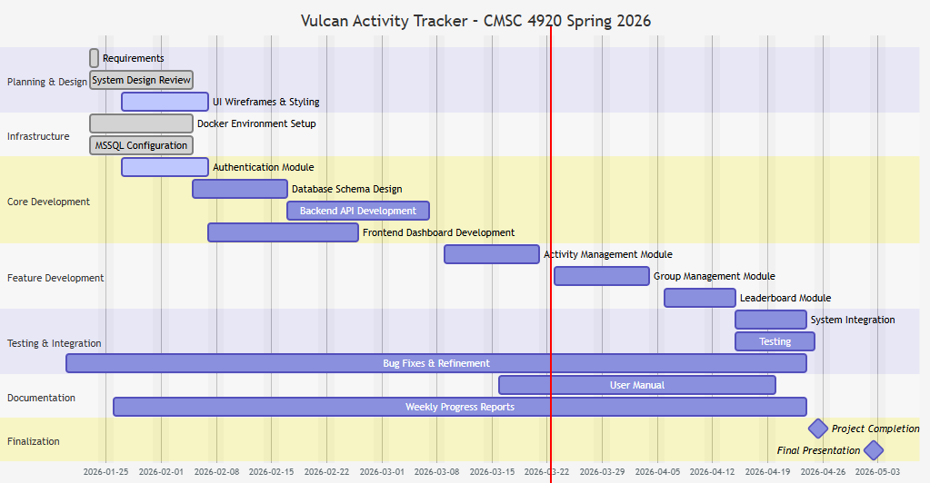

Week 14 Plan:
Our current plan for week 14 is going to focus on preparing us for our final presentation. First off we want to get a hard copy of our user manual printed, so it is ready to be turned in. Another goal we have for next week is to meet up and practice our final presentation slides as a group, so we can work on assigning slides to certain members and getting the flow of our presentation down. After practicing our presentation, we might slightly change our slides as needed, to help us give the best presentation we can. We also want to as always keep testing our project and fixing any bugs that may come up. This upcoming week we really want to focus on practicing and fixing our slides.

Member Contribution:

Team Members
Margo Bonal: | - Team meetings, Week 13 Report & Slides, User Manual
John Gerega: | - Team meetings, Week 13 Report & Slides, User Manual
Luke Ruffing: | - Team meeting, Week 13 Report & Slides, User Manual

